Liberate Garabagh

Design Document
(Homework No.2)

Project team: Gamers
Instructor: Dr. Araz Yusubov

Submitted in partial fulfillment of the requirements of the CSCI 4836: Game Development Fundamentals course project

Version date | Version information
17.10.2018 | Initial draft
21.10.2018 | Final draft

Team member | Contribution to this homework (NOT the project) | Estimated %
Zohrab Musayev | <Description of the work contributed> | <X>%
Nezir Yunuszadeh
Arzu Mammadova | 3
Samad Samadzade

Table of Contents
<Automatically generate here using Microsoft® Word menu References→Table of Contents>

<This document describes how game objects behave, controlled and properties they have. This is often referred to as the “mechanics” of the game. This documentation is primarily concerned with the game itself. This part of the document is meant to be modular, meaning that you could have several different Design documents attached to the Concept Document.>

Introduction
This is part of the Game Design Document for a hypothetical project Liberate Garabagh submitted for partial fulfillment of the requirements of the Game Development Fundamentals course in the School of Information Technologies and Engineering at ADA University, Baku, Azerbaijan.

< While doing further planning and getting better understanding of the project you may need to make changes in the HOMEWORK 1 content, such as additions/modifications to the Game Play or to Definitions. In this case edits in the Homework 1 content should be visible by turning the TRACK CHANGES option on through Review→Track Changes menu. Remember that the version information on the title page should be updated.

After starting the second homework, we decided to make a game in a 3D format which seems to be more interesting to play with more precise graphics. Also,

Bonus: Get extra 5% points for revising and SUBSTANTIALLY improving the Homework 1 content.

All Microsoft© Word documents should be submitted as separate files. Any additional files of other types e.g. diagram and charts will usually be inserted to this document as embedded images, but the source files e.g. Photoshop .psd files should also be submitted. In this case (of having multiple non-Word files) all of them should be submitted as part of a SINGLE .zip archive file.>

< In this section, the definition of the game-play is established. Definitions should include how a player wins, loses, transitions between levels, and the main focus of the game-play. Issues that should be addressed here are:
- Menu
- Synopsis
- Game Play
- Player Control
- Game Over (Winning & Losing)
>

Game matrix
< The game matrix is a spreadsheet containing the generic names of the player and antagonistic elements and their game properties. This should allow an easy cross reference for any elements in the game that have numerical or other descriptive values associated with their name.>

Game Flow Chart
<The game flow chart provides a visual of how the different game elements and their properties interact. Game flow charts should represent Objects, Properties and Actions that are present in the game. Flow chart objects, properties and actions should have a number reference to where they exist within the game mechanics document.>

Player Elements
<The player elements section lists all the elements that are directly related to the player or serve to benefit of the player. Devise two sets of names for player elements. One set is a generic name (or code) and the other is its game name. Describe the terminology that you use to describe the player’s properties.
This is a good place to interact with a graphic designer to ensure the game graphics match the game names. Graphics that will be seen during game play should be exhibited here. Multi-player issues should also be mentioned here.>

Player Definition
<Use the player definition section to make quick descriptions that define the player.
Below is a suggested list of player definitions:
- Default (Status): What are the default settings for the player at the beginning of the game or level?
- Actions: What can the player do?
- Information (Status): What information about the game is available for the player?
- Default Properties: How does the player begin the game?
- Winning: How can the player win?
- Loosing: How does the player lose?
>

Player Properties
<Make a list within the player properties section that defines the properties for each player. Player properties can be affected by player’s action or interaction with other game elements. Define the properties and how they affect the player’s current game. A suggested list of player definitions may include:
- Health
- Weapons
- Actions
- Etc.
Each property should mention a feedback as a result of the property changing.>

Player Rewards (Power-ups & Pick-ups)
<Within the player rewards section, make a list of all objects that affect the player in a positive way (i.e. health replenished). Define these objects by describing what affect they cause and how the player can use the object.>

User Interface (UI)

One of the important factors to succeed in a game development is to have a well-designed User Interface. So, to make it easy for a new player to interact with the game, we chose the best and simple ways. Firstly, welcoming page will be displayed when the user starts the game. It will consist of the game’s name followed by the main menu which will have some parts like new game, resume the game, quit the game and its settings/options. The settings part will contain some options to choose the desired tank from the list. After starting the game, to move the Tank a user must use the arrows (left, right, straight, back). Secondly, to have a fire shot from the tank’s pivot space button should be used. Then, touchpad or mouse rotating should be used to rotate the head of the tank around the screen.
Additionally, we will have 2 types of view related to camera control, where the first one will have the larger view from the back side of the tank where you will have an opportunity to completely see the player which is Azerbaijani tank in our case. The second one will utilize the view from the tank’s pivot.

Buttons to move 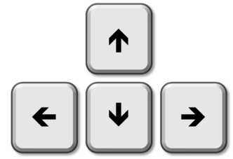

A button to fire 

For rotation 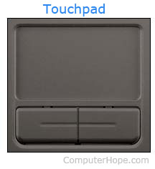

Types of view:

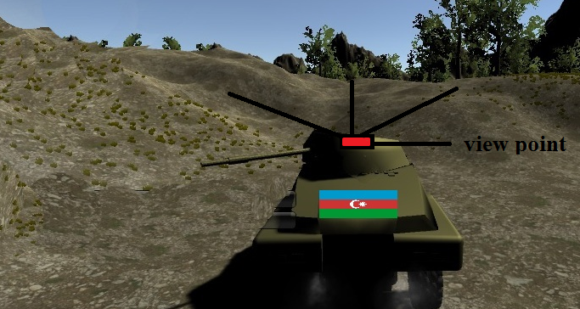
The whole picture describes the first view which is the larger one from the back side of a tank as you can see on the picture. As noted with a red color on the picture, the second one stands for the view from the tank’s pivot.

Heads up Display (HUD)

During the game, the user will have an opportunity to see some details about his/her current state including Health and Bullets. Also, Pause button will appear on the screen to make a pause or to go to the Menu bar.

- Health - it will show the health percentage of a player which is 100% as a default in the beginning of the game
- Bullets – as the player will have a limited number of bullets for a shot, we will have the remaining part shown on the screen
- Pause – this stands for pausing the game or making any changes to the game by choosing continue, new game or quit the game buttons.

100 % 
20 bullets

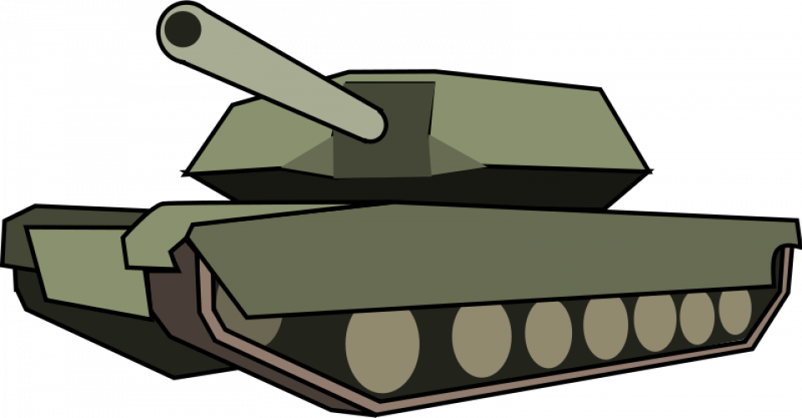

Player View

Here is the screen shot of the player view that we have for now. Precisely, the camera is in 3D format and it follows the player which is the tank in our case.

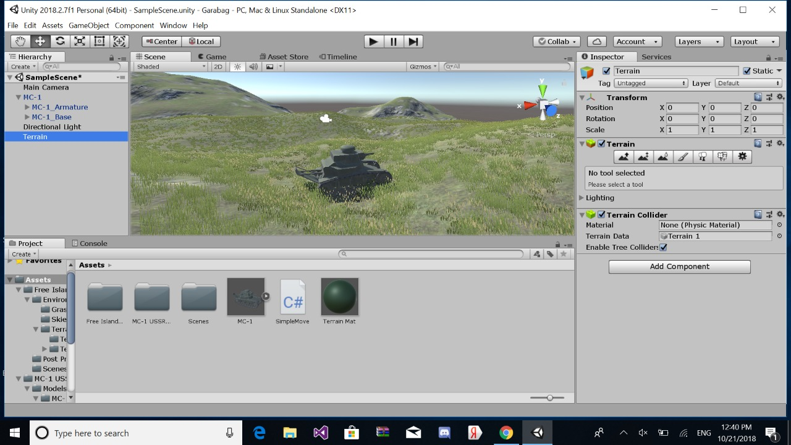

Antagonistic Elements
<This is where a list of antagonistic (i.e. enemies, opponent) objects should be listed with graphics and written description. Describe the terminology that you used to describe antagonistic properties. Devise two sets of names for player elements. One set is a generic name (or code) and the other is its game name. This is another good place to collaborate with a graphic designer to ensure the game graphics match the game titles, names, and descriptors. >

Antagonistic Definitions
<This where a description goes of what makes an antagonistic element.>

Antagonistic Properties
<This is a list of properties that antagonistic elements have in common.

Antagonistic List
<This is where a list of all the antagonistic elements goes.>

Artificial Intelligence (AI)
<This is where visuals and written description(s) of the antagonistic element’s behaviors. These should be labeled in such a way that they can be used in level design without having to describe them again. Devise generic names for repetitive behaviors. This is how an AI action could be deconstructed:
- Normal State: What is the object doing if it has not come in contact with the player?
- Detection State: What does it take for this object to detect the player?
- Reaction State: What does the object do as an action after passing the reaction state?
- End State: What happens to the object after player has reacted correctly or incorrectly to object?
>

Global Game Elements
<In this section, it is important to describe the boundaries, neutral objects, camera views and scale of the world. Neutral game world objects can be things like a static background, objects that do not interact with the player or antagonistic elements.>

The Story
<This is where the story can be described in detail. A story board can be used to tie in graphics to the text. This can later be used for splash screen concepts.>

The Story Copy
<A shorter version of the story (the in game version) should also be written here. This is where the script for in game characters or story information during the cut scenes would be placed. This category does not always pertain to the current Game Design.>

Concept Art
<Sketches that are used for the concept can go into this section as visual reference. In the case of a brand, certain creative restrictions should be noted here. This is a good place to collaborate with a graphic designer to ensure game graphics match game names.>

Level Design
<This is where information pertaining to level design and visuals of the level design goes. Level design can best be shown as a flow chart. Use generic names to create level design.>

Level Copy
<This is where the script for in game characters or story information during the cut scenes would be placed.>

Audio & Sound F/X
<This is where game audio and Sound F/X should be listed, first with generic names and then described. This section also includes deciding if you will use a device’s vibration ring mode.>

Game Architecture
<The game architecture section is best produced using a flow chart to represent the overall game. Be sure to identify (i.e. name, number) each screen.
- Title Screen
- Option Screens
- Game Modes
- End Screens
>

Game Architecture Overview
<The splash screens or video clips need to be in accordance to game story and style. If cut scenes use video then story boards should be created.
Menus should be designed with the most important options easily accessible. Be aware how many clicks it takes to accomplish a task. The game Instructions should be written so that the player understands how to play the game. Mock-ups should be made so that the game programmers get the correct layout of the menu. It is a good idea to mention and describe the high score screen in this section.>

Architecture Copy
<All text from the game can be compiled here. Review the Game Architecture Overview section.>

How to Play Copy
<This section will organize the game copy. The game copy includes information for the player, clearly describing how to play the game.>

References
<Insert here any document referred to in the document. An example might be articles or Web sites that you consulted during the literature search. This is not just a list of used materials, so do not forget to clearly MARK the exact points(s) of reference in the main text.>

